PORTABLE ANESTHESIA MACHINES «COLIBRI» &
VAPORIZERS «MINIVAP»
User’s Guide
Hospitals
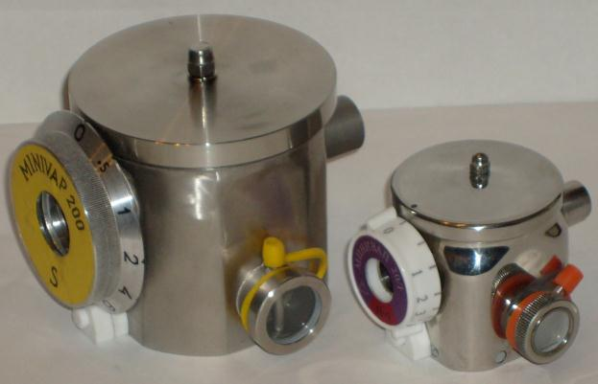  Vaporizers «MINIVAP-20/I» (to the right) and «MINIVAP-200/S»  stainless steel or titanium (MRI) |  | 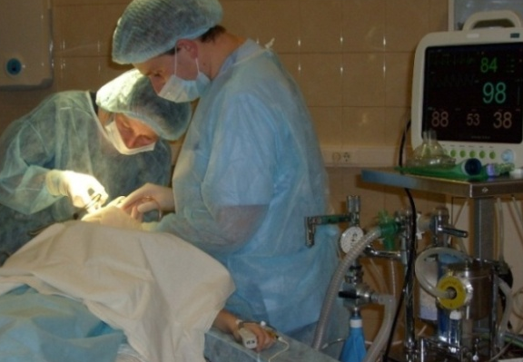  Vaporizer «MINIVAP-200/S» OUT of circuit  MK-110, Japan (maxillofacial surgery) |  |  |  |  | Vaporizer «MINIVAP-20/S» IN circuit of ventilator
Veterinary
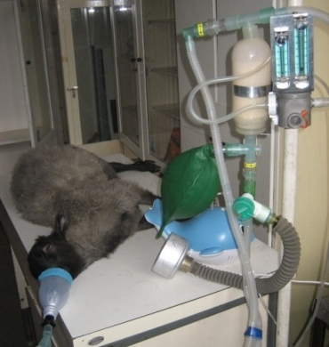 | 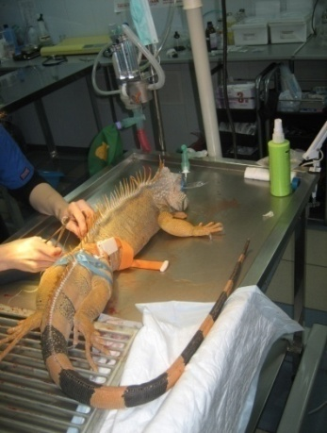 |  |  | 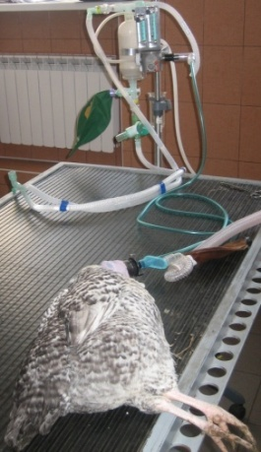 |  | 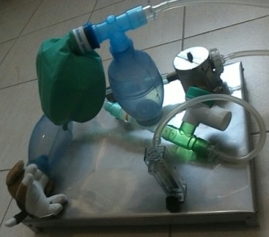  AM «Colibri» for small animals, vaporizer «MINIVAP-20/I» IN circuit
AM «Colibri», vaporizer «MINIVAP-20/I» OUT of circuit
Emergency & Military field
AM «Colibri» for Emergency & Military field: |  |  | 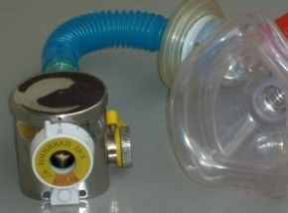  а – spontaneous breathing  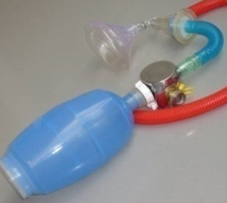  b - artificial ventilation of bag Ambu |  | 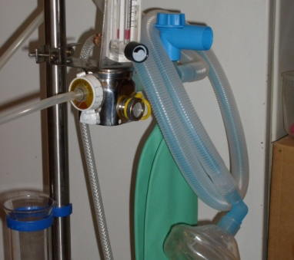  AM «Colibri» with Mapleson A breathing circuit
• Universal (work on compressed gas or ambient air with any anesthetics and any breathing сircuits)
• Effective (provide 10 MAC for the mouse at a gas rate of 0.1 L/min, and for a horse - at a rate of 20 L/min) and economical (10 times less the working anesthetic minimum and the residue after draining)
• Miniature (vaporizer "MINIVAP-20 / I» less mask)
• Compatible with any ventilator and O2 Concentrators (Armed, AirSep)
• Safe (vaporizer "MINIVAP-20 / I» works at any tilt)
• Stable when changing the gas flow rate (from 0.1 L/min), temperature and pressure
Portable Anesthesia Machines (AM) «Colibri» intended for inhalation anesthesia in hospitals as well as in the military field, emergency and veterinary medicine.

The AM «Colibri» is made in accordance with the requirements F1850-00 «Anesthesia Workstation and Their Components».

Registration certificate № FSR 2010/06696 of 01.02.2010
The Declaration of Conformity № ROSS RU.IM18D00129 on 16/09/2016

1. SAFETY PRECAUTIONS:
1.1. If you are replacing one of the anesthetic on the other it is not allowed the use of a mixture thereof.
Old anesthetic is necessary to drain and purge the vaporizer gas flow of 10 l / min until the disappearance of the smell (not less than 3 minutes). This concentration scale should be at the maximum mark, a fill (drain) pipe of the anesthetic - is open.

1.2. When operating the AM during transportation to fill no more than 20 ml of the anesthetic.

1.3. Monitoring of the breathing mix (anesthetic, O₂ and CO₂), breathing parameters and cardiovascular system is carried out with additional equipment.

2. Preparation and checking AM
2.1. Set the AM to support for transfusion with a bracket (Fig. 6-8) at the optimal distance from the patient and a source of oxygen.
Check correct assembly of the AM (the most complex model - in Fig. 7, 13).

2.2. The leak tightness of the breathing circuit.
Check the leak tightness. Close the pressure safety valve (see Fig. 13, the "green hat" turn it clockwise until it stops). Inflate the breathing bag (oxygen through the flowmeter or air through the patient's T-pipe). If the unit is sealed, the bag does not subside quickly (no more than 1/3 of the bag volume for 1 minute) against a closed T-pipe and flowmeter.
Take a couple of inspiration- exhalation through the patient's T-pipe: during exhalation bag attached to the adsorber is filled, with inspiration - emptied; respectively unidirectional valves are opened (by the directional arrow) on the lines of inspiration and exhalation.

2.3. Anesthetic fill is performed using a syringe (eg 20 ml, not included), and a flexible tube. Fill the syringe from the vial of anesthetic, and then attach the free end of the tube to the fill (drain) pipe (Fig. 1). At filling follow the anesthetic level - not exceed the maximum mark.
For sevoflurane first screw onto the neck of the vial anesthetic adapter (Fig. 2), and then fill the syringe from the vial and the vaporizer as in the previous case.
Repeat anesthetic fill (usually syringe is less of vaporizer capacity) and close the fill (drain) pipe.
When using vaporizer «MINIVAP-20 / I» (weight 0.4 kg) during patient transportation (stretcher, car, helicopter) to fill no more than 20 ml. In the case of the anesthetic overflow and its contact with the vaporizer outlet, the one must be purged along with the breathing circuit to the complete disappearance of the smell.
WARNING: Do not forget to close the fill (drain) pipe.
Anesthetic drain from the vaporizer is made similarly to fill with a syringe. Thus the vaporizer can be tilted towards the sight glass. Aspirated anesthetic until its level does not drop to the bottom. Not more than 3 ml of anesthetic remains in the vaporizer chamber after draining.
Close the fill (drain) pipe with stopper.

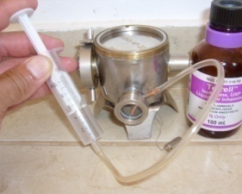  Fig. 1 | 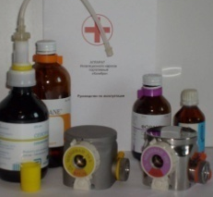  Fig. 2 | Fig. 3

2.4. Anesthetic concentration. The required value of the scale concentration set opposite the marking on the cover of the vaporizer. To rotate the scale counter-clockwise from «0», press the release button below the one.
In special cases, when using a vaporizer «MINIVAP» for different anesthetics necessary to make a correction of the scale using the conversion factor (remember that this introduces additional error).

Example 1:
- Vaporizer «MINIVAP-20/I» (scale for Isoflurane) is used for Sevoflurane. Then all scale marks is divided by a factor of 1.5.
Thus, at the mark «1» sevoflurane concentration is 0.7 vol.%, at the «6» – 4 vol.%, respectively.
- Vaporizer «MINIVAP-20/S» (scale for Sevoflurane) is used for Isoflurane. Then everyone of the scale is multiplied by a factor of 1.5.
Thus, at the mark «1» isoflurane concentration is about 1.5 vol.%, instead of «4» –
6 vol.% respectively.

In the absence of the gas analyzer, in special cases, the vaporizer operation is checked by the smell.
Control of «0». Set vaporizer scale at «0», and the inhaled gas is to be odorless.
As the rotation vaporizer scale in the direction of increasing concentration, the smell of anesthetic should appear and gradually increase. It should be limited to the minimum amount of inhalation anesthetic vapor (T-pipe to keep at a distance from the nose).
NOTE: In medium and large gas flow rates (4 L/min or more) and scale marks (about 2 vol.% or more), the outlet concentration of the vaporizer «MINIVAP-20/I» (weight 0.4 kg, Fig. 3, right) is reduced due to intensive evaporation of the anesthetic (in 3-5 min).
This feature should be taken into account when planning and choosing anesthesia methods: preferably working in a mode of low-flow anesthesia.
Vaporizer «MINIVAP-200/S» (Fig. 3, left) calculated for patients weighing up to 300 kg and stably doses anesthetics throughout the scale range from 0 to 10 vol.%.

Table 1
Technical Data of «MINIVAP» vaporizers
Data | «МINIVAP-20» | «МINIVAP-200»
Concentration Range of S or I or H or E, vol.% | 0 - 6 | 0 - 10
Temperature Range, ^{о}С | 5 - 35 | 15 - 35
Atmosphere Pressure Range, kPa | 70 - 110 | 70 - 110
Gas flow range, L/min | 0,2 - 10 | 0,2 - 20
Resistance to flow 10 L/min, mm H₂O | 20 | 10
Anesthetic Volume, ml | 40 | 100
Wick Anesthetic volume, ml | 3 | 5
Max Angle of Tilt during operation | 180^{о} | 90^{о}
Weight, kg | 0,4 (0,3 of Ti) | 1,5
Inlet / Outlet | 15F/15M | 22F/22M

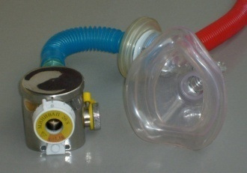  Fig. 4 | Fig. 6 | 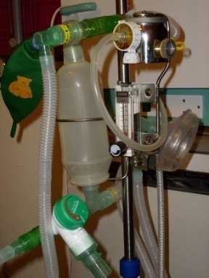  Fig. 7
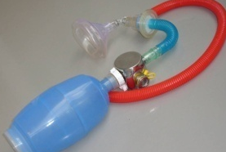

Fig. 5
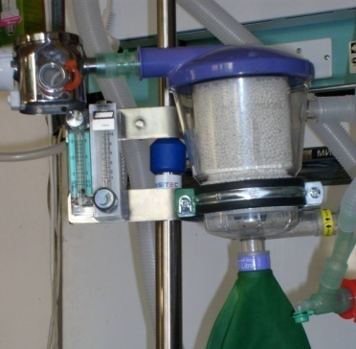  Fig. 8 | 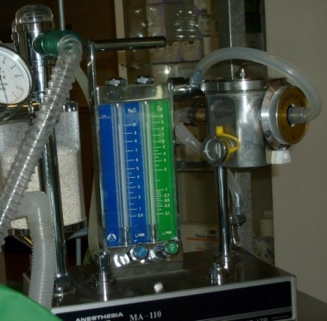  Fig. 9 | Fig.11

3. AM Work
3.1. Open circuit. With spontaneous breathing the vaporizer inlet is opened, and the outlet is connected via a non-reversing valve and face-mask to the patient (Fig. 4).
Inspire air is saturated with anesthetic vapor to the desired concentration, and the expire gas through the non-reversing valve nozzle withdrawn from the surgical field into the atmosphere.
At manual ventilation Ambu bag is connected to the vaporizer inlet (Fig. 5).

3.2. Semi-open Mapleson A breathing circuit (Fig. 6, is most effective during spontaneous breathing) is connected to the vaporizer outlet, inlet of one is connected to the outlet of oxygen flowmeter.
During expire «dead space» gas is held together with the oxygen in the breathing bag, and alveolar gas with a high C_{O2} content is discharged through the safety valve (located at the mask) into the atmosphere. If you set the oxygen flow third less minute ventilation of the patient and adjust the safety valve periodically filling and emptying without inflating or sticking breathing bag, while saving up to one third of oxygen and anesthetic.

3.3. AM «Colibri» Semi-closed circuit with VOC (Vaporizer OUT of Circuit).
Expire gas portion is returned to the circuit and cleaned in a sterilizable adsorber (Fig. 7) or in the Clear-Flo «Intersurgical» adsorber (Fig. 8), and then inhaled by the patient together with the fresh gas mixture.
To install «MINIVAP» vaporizer OUT of breathing circuit of any other AM or Ventilator, need the input and output of the vaporizer are respectively connected to the dosimeter and the breathing circuit of the machine (Fig. 9).
Inspire anesthetic concentration over time, is approaching of the scale vaporizer concentration C_{I} → C_{V}.
3.4. Semi-closed circuit with VIC (Vaporizer IN Circuit)
In this case, the entire respiratory mixture passes through the vaporizer with maximum anesthetic flow in the AM breathing circuit.
Isoflurane inspire concentration change during anesthesia induction (without taking into account the absorption of anesthetic by the patient's body) is shown in Fig. 10 and, depending on the oxygen supply and minute ventilation ratio F_{O2} / MV, set at
C_{I} = C_{V} / [(C_{V} / C_{as}) + F_{O2} (1-C_{V}) / MV (1 - C_{as})], (1)
where C_{as} – anesthetic saturated vapor concentration.

Fig. 10. Isoflurane inspire concentration change of AM «Colibri» VIC depending on the ratio F_{O2} / MV
(C_{V} = 5 vol%; MV = F_{Circle} = ΔV x f = 0.2 x 30 = 6 L / min, where ΔV - volume change Ambu bag, L; f - frequency,
min⁻¹, the circle volume about 1 liter)
Inspire anesthetic concentration can be much higher! (See Fig. 10) the scale vaporizer concentration at a low (relative minute ventilation MV) the oxygen supply F_{O2}.

Example 2. When oxygen flow F_{O2} = 1 l / min and minute ventilation MV = 5 l / min (curve F_{O2} / MV = 0.2 in Fig. 10) the inspire concentration C_{I} on the scale mark C_{V} = 5% up to 10 vol. %!

NOTE: Vaporizer IN breathing circuit requires an anesthetic gas analyzer and highly skilled anesthesiologist!

While using the additional machine vaporizer «MINIVAP» directly connected to the pipe 22M at inhalation line of the patient (Fig. 11).

3.4.1 AM «Colibri» VIC for small animals (up to 3 kg, Fig. 12).
Inspire anesthetic concentration increases by the circulation of breathing gas through the vaporizer by means Ambu bag, also placed inside the breathing circuit. This method is particularly effective for patients with small minute ventilation.
Here, the gas circulating through the vaporizer can be estimated by squeeze frequency and amplitude of Ambu bag.
Methods of Work AM «Colibri» VIC:
A - To achieve the maximum inspire anesthetic concentration is necessary vaporizer scale mark at a maximum, close the pressure relief valve, and with a maximum frequency and amplitude squeeze the Ambu bag, attached to the patient (a little patient can be placed inside the bag through a removable cover).
Example 3. If the Ambu bag (volume of 300 ml) is squeezed at a frequency of 10 cycles / min, the gas circulation through the vaporizer about 2 l / min (0,2L x10 min⁻¹), whereas the inspire concentration C_{I} reach 10 vol.% in the circle (volume 1 liter) at scale mark C_{V} = 6 vol.%, air flow 0.5 l / min with a second bag Ambu (Fig. 12a) or O₂ throw flowmeter (Fig. 12b) according to equation (1) and Fig. 10 (ratio F_{O2} / MV = 0,25).

Usually have additionally supply oxygen or air into the breathing circuit due to leakage of the connection mask to the patient-animal, even with a closed pressure relief valve.
In case of short-term operations and a non-hermetic connection of the patient to the mask, when the suction of atmospheric air is more than the patient's metabolic requirement for oxygen, the absorber 15 can be excluded from the breathing circuit 5 (Fig. 12a).
B - To reduce the inspire anesthetic concentration necessary to reduce the vaporizer scale and a gas circulation.
Example 4. At scale mark «1» inspire concentration in the previous example is about 2 vol. %. If reduced circulation rate up to 5 cycles/min (1 l/min), the inspire concentration further decrease up 1,3 vol.%.

C - To stop the anesthetic supply, vaporizer scale should be set to zero, completely open the safety valve and blowing breathing circuit apparatus, no less than 10 times to squeeze the Ambu bag, feeding simultaneously into the circuit at least 2 L / min of oxygen or air.
It's a simple action prevent hypoxia and hypercapnia the patient at the same time!

Example 5. Weight of the patient 1 kg (metabolic consumption about 4 ml / min O₂), breathing circuit volume 1 L. Then 10 simultaneous key presses of two Ambu bags 300 ml will provide triple rinse of the circuit (blowing into the circuit 10 x 0.3 = 3 L of air with its simultaneous circulation).
In this circuit the O₂ concentration is not less than 15 vol.% (PaO₂ = 114 mm Hg) and CO₂ - not more than 5 vol.% (PaCO2 = 38 mm Hg), compare Table 16, p. 81. Veterinary anesthesiology. Nechayev AY et al. 2010.

On the small and middle scale marks C_{V}, when the relative supply of oxygen
F_{O2} / F_{Circle} ≥ 0.5, the inhaled concentration is proportional to minute ventilation (circulation) and inversely proportional to oxygen (or air) flow rate F_{O2}
C_{I} ≈ C_{V} MV (1 - C_{as}) / F_{O2}, (1a)
where MV = F_{Circle}, C_{as} - saturated vapor concentration of anesthetic.

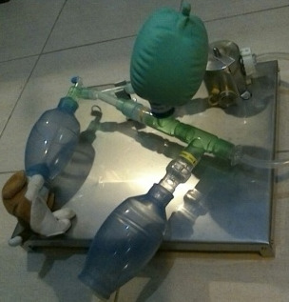  а –with a second Ambu bag for air supply | 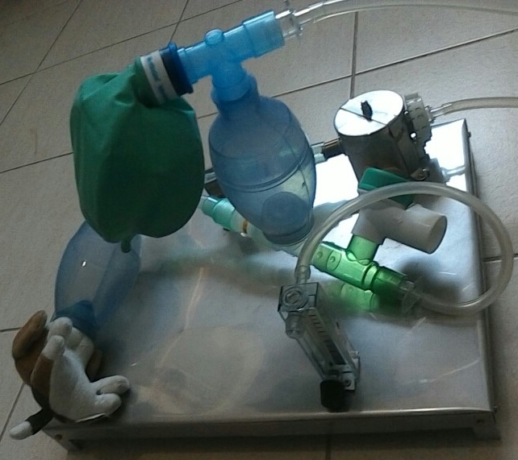  b – with a flowmeter, adsorber (vertical Ambu) and the safety valve
Fig. 12. AM «Colibri» VIC for small animals

3.5. When using the ventilator his T-pipe with inhalation and exhalation tubes are inserted into the circuit of AM «Colibri» instead of the breathing bag.

3.6. Replacing the waste adsorbent
Replacing the waste adsorbent (indication «white → violet».
Upper T-pipe with mesh to remove from silicone canister (Fig. 7, 13), pour the spent adsorbent from the canister through the hole 22 mm, fill the fresh adsorbent and reinsert the T-pipe.
During the low-flow anesthesia is advisable to apply the adsorbent LoFloSorb «Intersurgical», prevents the formation of toxic CO and Compound A.

3.7. Consumption of liquid anesthetic during the anesthesia induction and maintenance was calculated from the ratio
V ≈ k_{A} (C_{V1} F_{G1} t₁ + C_{V2} F_{G2} t₂), (2)
where for Sevoflurane k_{S} = 0,055; for Isoflurane k_{I} = 0,051; F_{G} – vaporizer gas flow, t₁, t₂ - anesthesia induction and maintenance duration, respectively.

Example 6. Isoflurane induction, at a concentration of 5 vol% and a oxygen flow rate 6 l/min, continued for 5 minutes, and during the surgery (60 min) at average concentration level 1.5 vol% and flow rate 1.5 l/min. Then, the total consumption of Isoflurane was, according to the table 2, about 15 ml (7.7 + 6.9 = 14.6).

Table 2
C_{V}, об.% |  | F_{G} , л/мин | t₁ , min |  | t₂ ,min |  | (t₁ + t₂), hour
 |  |  | 2 | 5 | 30 | 60 | 0.5 | 1 | 2 | 3
S | 8 | 6 | 5.3 |  |  |  | 8.5 | 12 | 18.5 | 25
 | 2 | 1 |  |  | 3.3 | 6.6
I | 5 | 6 |  | 7.7 |  |  | 11 | 15 | 21.5 | 28.5
 | 1.5 | 1.5 |  |  | 3.4 | 6.9

3.8. The order of the AM «Colibri» assembly semi-closed circuit with sterilized adsorber -according to Fig. 13 (see 2.1 and Fig. 7)

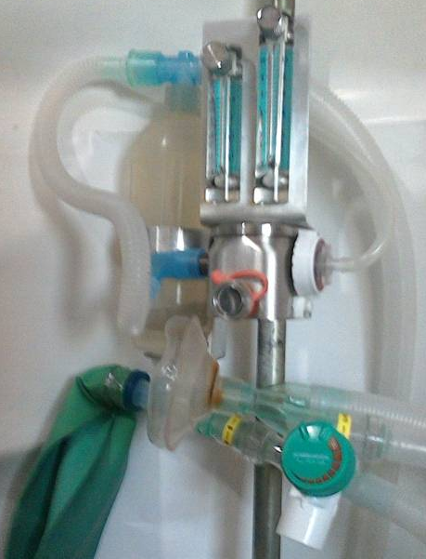
5
7
8
6
1
3
4
2
1 – vaporizer 5 – safety valve
2 – flowmeters 6 – T-pipe with face-mask
3 – adsorber (sterilized) 7 – inspire valve ("arrow" to the T-pipe)
4 – bag 8 –expire valve («arrow» to the adsorber)
Fig 13. AM «Colibri» with semi-closed circuit

4. WARRANTY
4.1. The manufacturer guarantees the machine with regulations in compliance with conditions of use, storage and transportation.
4.2. The warranty period of the device - 2 years from the date of sale.
The warranty period of the breathing circuit elements (bags, valves, pipes, etc.) - according to their passports.

5. ACCEPTANCE CERTIFICATE
Portable Anesthesia Machine «Colibri»
Factory number ____ corresponds to TU 9444-001-99669174-2016 Date of issue _________

Director of Scientific & Manufacture Firm “MINIVAP” Ltd. ___________ Alexander Berlin
aleberlin@mail.ru Moscow + (499) 907 2872 & Israel +09 7929079 www.minivap.net

