MINIVAP Anesthesia Kit

Instructions for Use

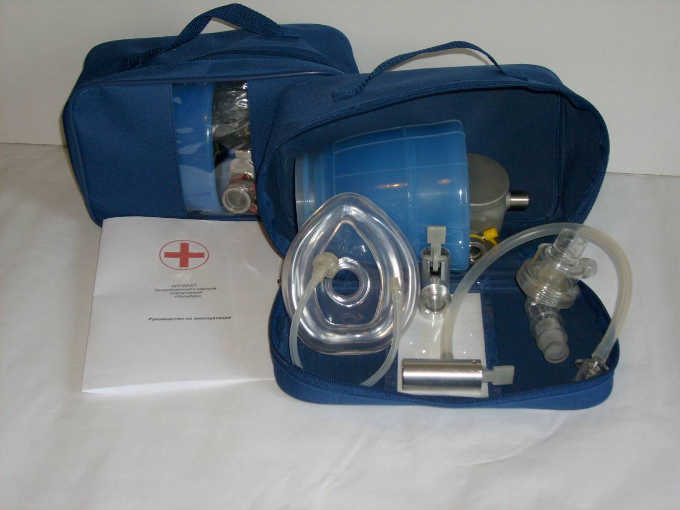 | 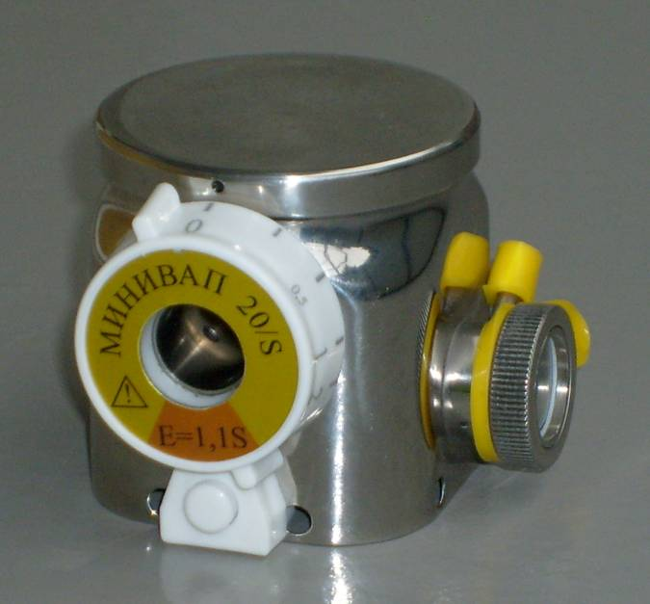
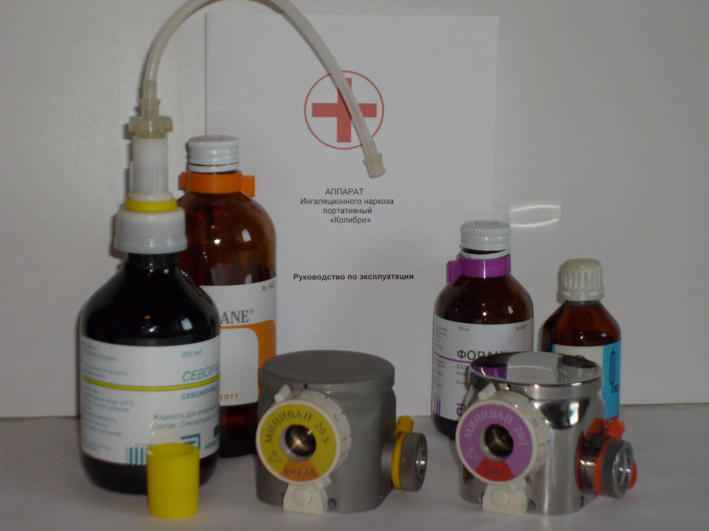 | 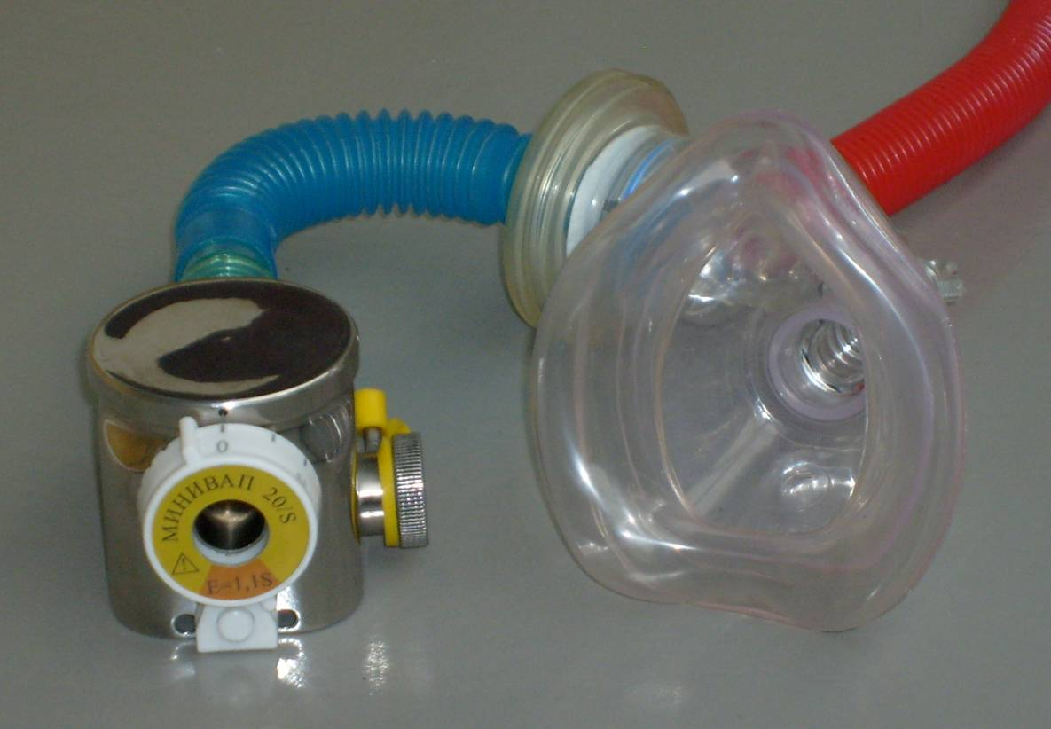
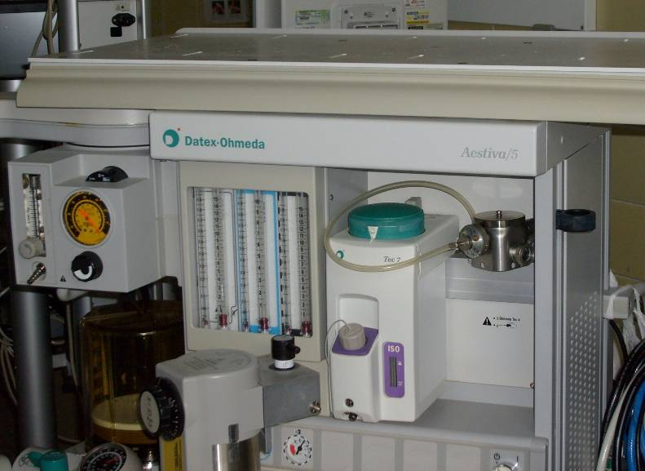 | 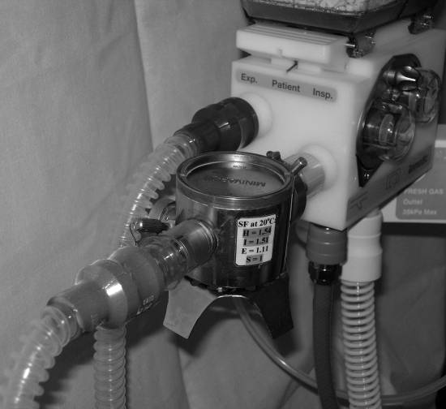

Contents

Name | Page
Intended Medical Application | 2
Preparation | 3
Operation | 5
Care | 6
Technical Data | 7
Anesthesia Kit description | 8
References | 10

Intended Medical Application

The MINIVAP Anesthesia kit is instantly adaptable between the needs of on-site emergency surgery (military, urgent situations & remote areas and veterinary anesthesia), and the more sophisticated demands of the general/district hospitals.
A modular format of this kit give an opportunity of the user to custom-build an anesthetic system optimally suited to the prevailing situation.
It consists of a low resistance vaporizer MINIVAP-20 (MV-20) that can be used in either draw-over or plenum modes.
MV-20 vaporizer accurate enriches of fresh gas (ambient air or compressed gas from flowmeter) with the vapors of the relevant anesthetic:
for Sevoflurane MV-20/S up to 4 vol. %, MV-20/S* up to 8 vol. % - the last is only plenum mode;
MV-20/I, MV-20/H, MV-20/E - for Isoflurane or Halothane or Enflurane accordingly.
Then the gas mixture is delivered to a patient by means of his breathing efforts or manually with a self-inflating bag or a reservoir bag, or automatically with a ventilator (not in the kit).
Due to the low resistance (about 10 mm H₂O with the exception of MV-20/S*) and virtual independence from the gas flow rate from 0.2 to10 L·min⁻¹, the vaporizer may be both installed in conventional breathing circle (VIC at intermittent gas flow) and used out of it (VOC at continuous flow).

For your Safety and that of your Patients
- Strictly follow the Instructions for Use.
- Only fill the vaporizer with the anesthetic for which it is designed. If the wrong anesthetic is used the patient may be harmed.
- Use only dry, pure air or medical gases.
- Liability for the proper function of the apparatus is irrevocably transferred to the owner or operator to the extent that the apparatus is serviced or repaired without author’s consent or if the apparatus is used in a manner not conforming to its intended use and damage caused by non-compliance with the recommendations given above.

Preparation

Check that vaporizer is not damaged.

Vaporizer connecting
There are inlet and outlet openings in form of 15-mm conical female and male fittings correspondingly.
Make sure that only one vaporizer can be used at any one time. Never connect vaporizers in series.
Connect the vaporizer to breathing circle:
Open circle (intermittent air flow): the vaporizer inlet is open or connected with self-inflating bag; the outlet is connected directly to a facemask by means of a non-rebreathing valve (Fig. 1). An expired fitting of the non-rebreathing valve is connected with scavenging system.

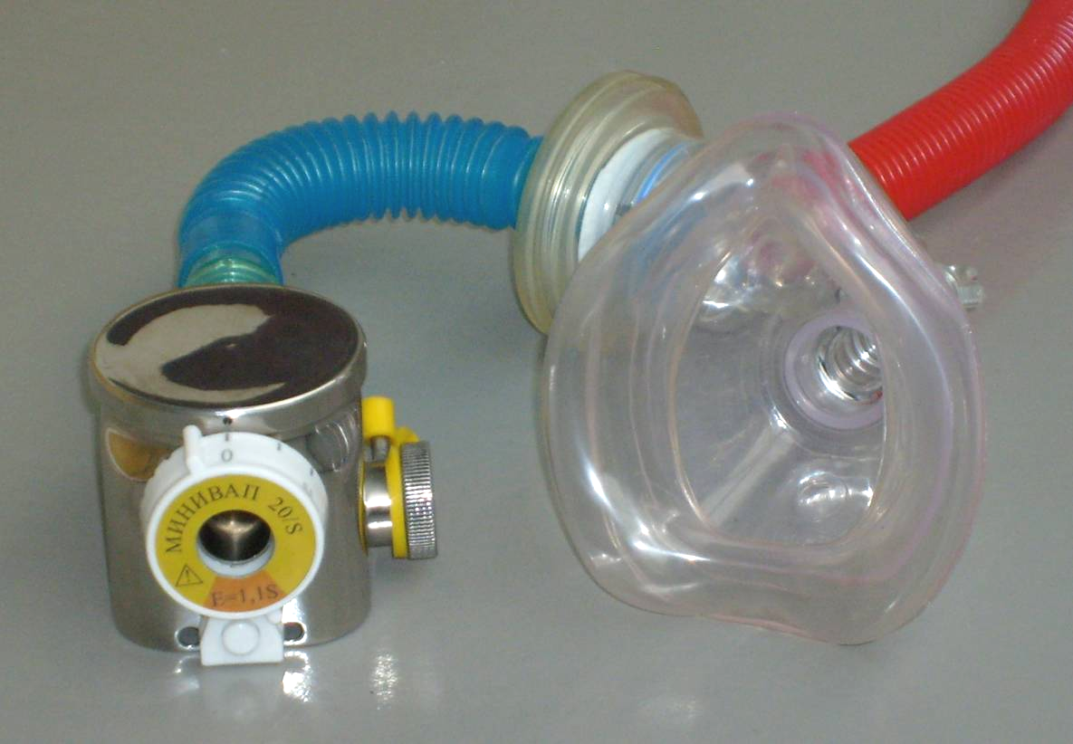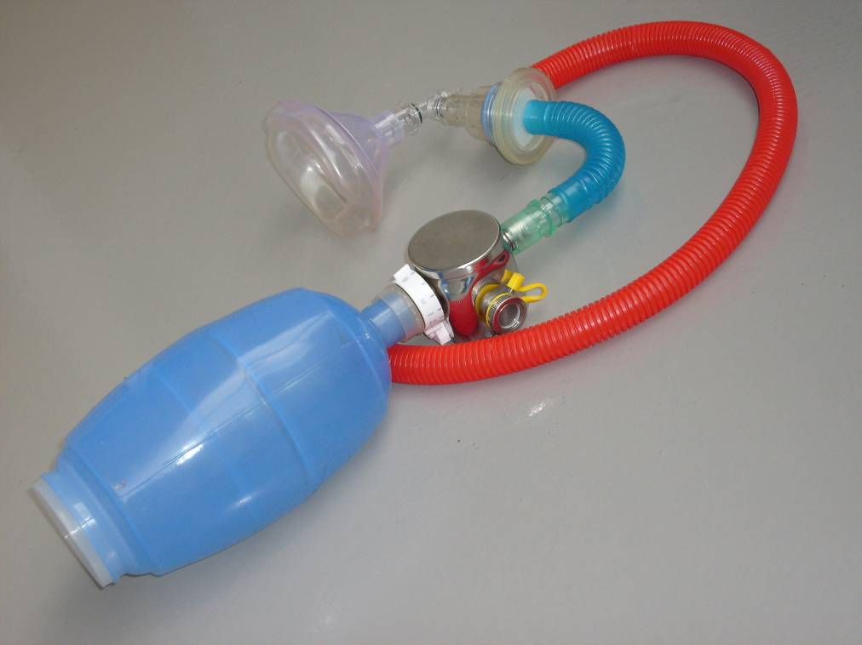
a) b)
Fig 1. MINIVAP Anesthesia kit: open circle at spontaneous breathing (a) or with the self-inflating bag)

Semi- closed and closed circles (continuous fresh gas flow): the vaporizer inlet is connected with flow meter by inlet adapter with flexible tube; the outlet is connected with a convenient breathing circle of a standard anesthesia machine by outlet adapter (Fig. 2).
Skilful anesthetists can install MV-20 IN the breathing circle between an inspired fitting 22M and a corrugated tube of any anesthesia machine (Fig. 3).

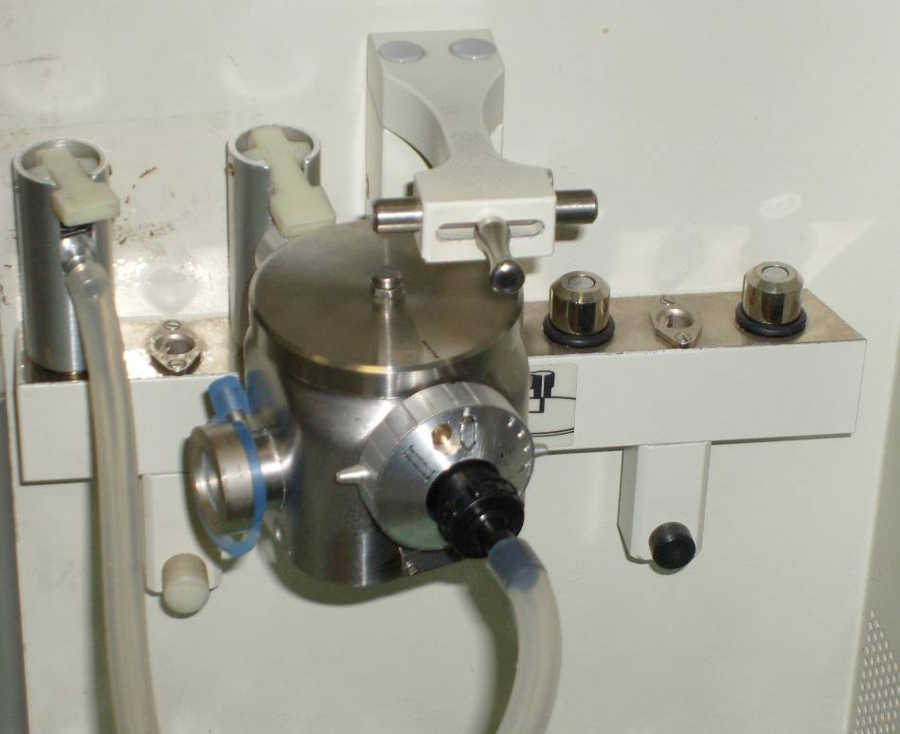
a) b)
Fig 2. MINIVAP-20 is OUT of circle: a) Datex-Ohmeda; b) Drager Primus with inlet and outlet adapters

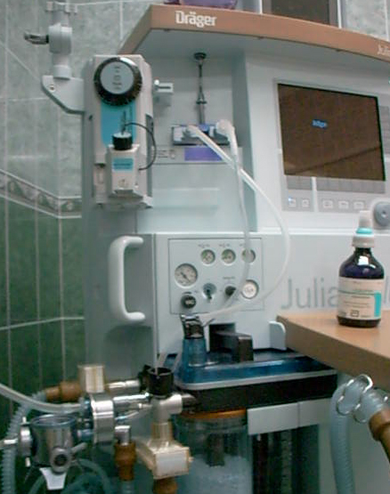
a) b)
Fig 3. MINIVAP-20 is:
a) IN a circle of Falcon CE (inspire line); b) IN or OUT position with special valve

Filling vaporizer
Keep the vaporizer vertical while it is being filled. Connect Sevofluran bottle with vaporizer filling tube by means of a filling adapter. Sevofluran would be squeezed out from a bottle at upper position through the filling-draining adapter (Fig. 4a).
Anesthetics may be filled too into the vaporizer with a syringe through a special tube (Fig. 4b).
Note liquid level through the glass anesthetic gauge. Fill from minimum (5-10) to maximum (30-40 ml) marks only.
If it is overfilled and liquid anesthetic flew into the outlet opening, then rinse the vaporizer and breathing circle with air or oxygen at a flow 10 L/min for 1-2 min up to disappearance of anesthetic smell.
When filling during operation the handwheel has been set to "0".
Close the filling cap.
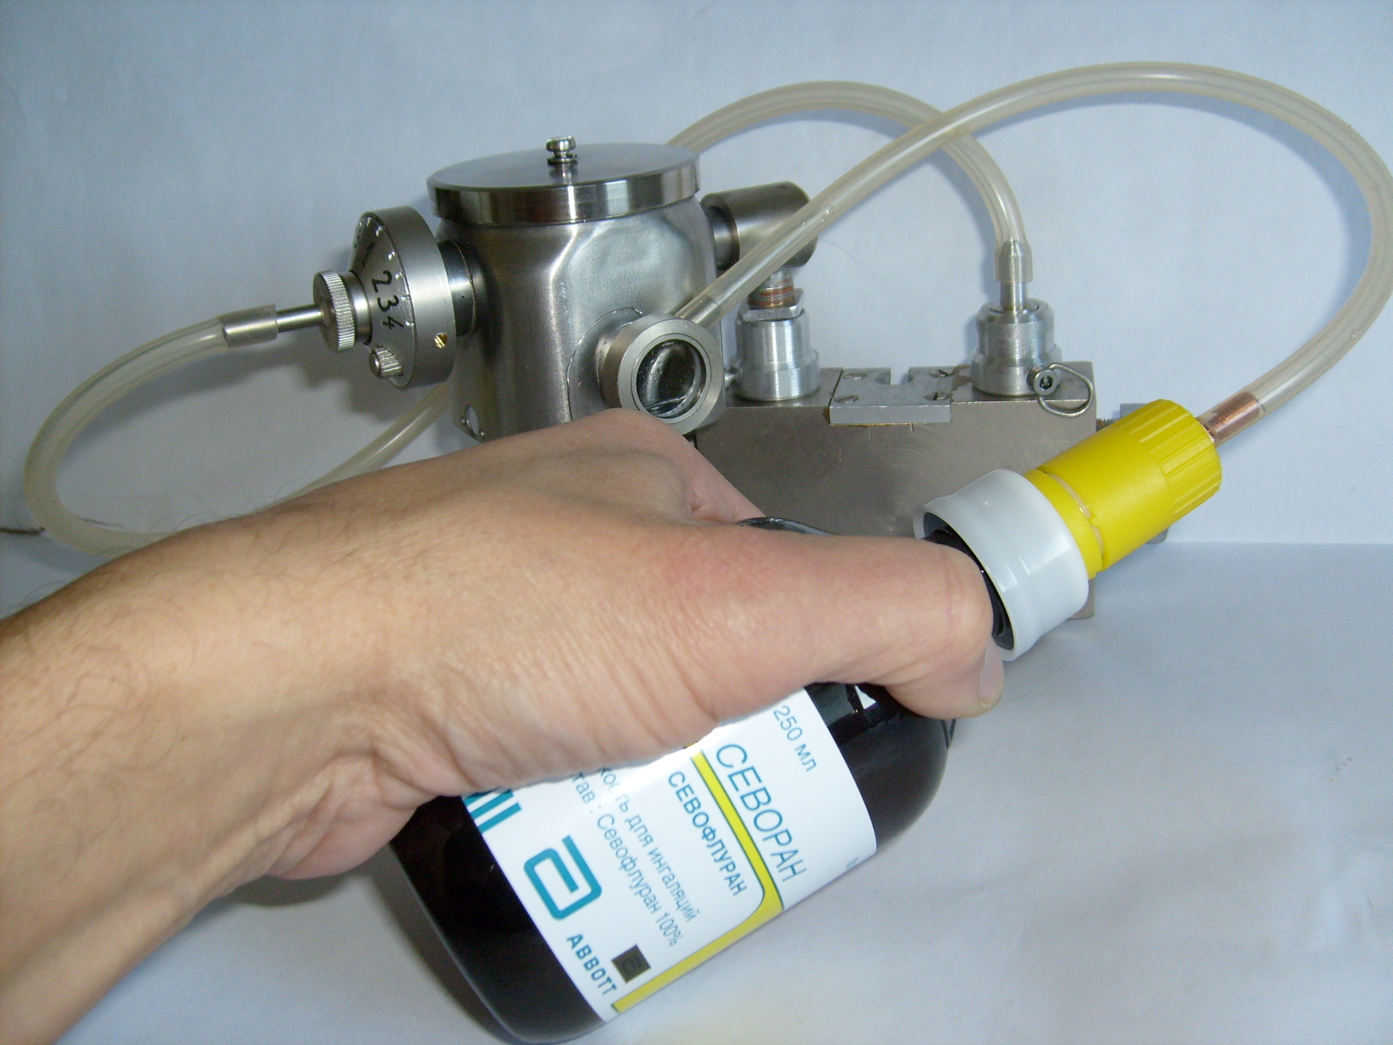
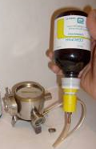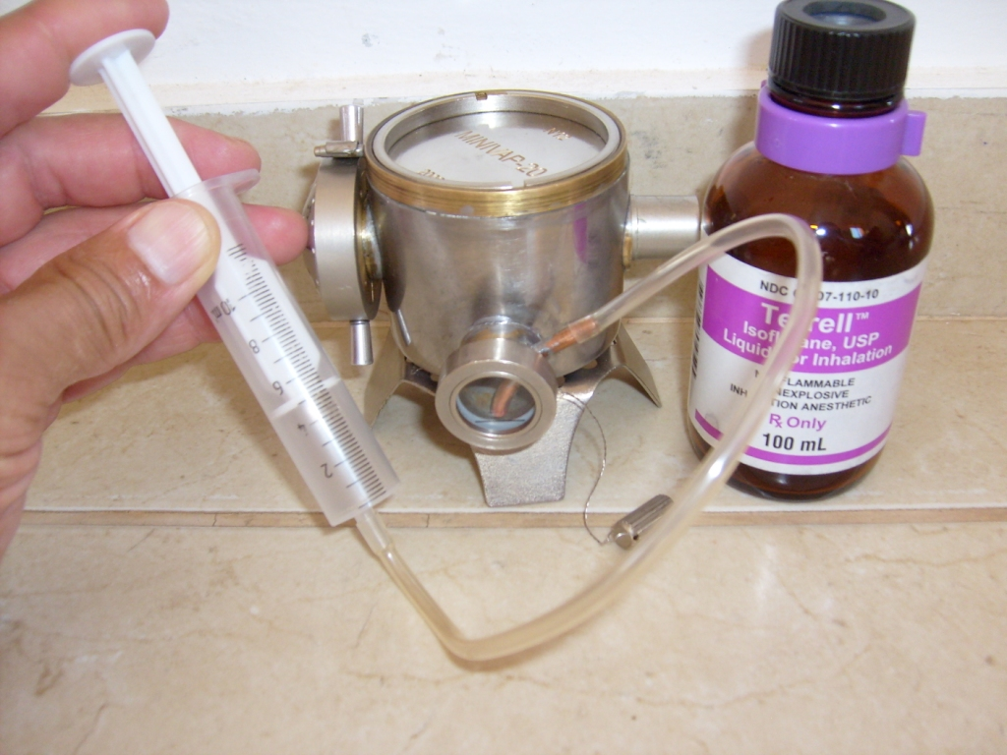

a) b) c)

Fig. 4. Filling (a) & Draining (b) vaporizer with Sevofluran and Isofluran (c)

Operation

Checks before starting anesthesia:
- There is enough an anesthetic in the vaporizer;
- Filling cap is closed;
- Handwheel is engaged at “0”;
- The vaporizer is connected to breathing circle properly;
- It is possible to operate ONE vaporizer at a time.

Setting anesthetic concentration
- First set flow of fresh gas on the flowmeters of other anesthesia machine if use semi-closed (absorber) circles (see Fig. 2);
- Press a fixation button and turn handwheel anti-clockwise from “0” to a concentration mark desired.

Consumption of liquid anesthetic by vaporizer during anesthesia induction and maintenance, ml

V ≈ k (С₁ F₁ τ₁ + С₂ F₂ τ₂), (1)

where for Sevoflurane k_{S} = 0,055; for Isoflurane k_{I} = 0,051; C - vaporizer scale concentration, vol.%; F – fresh gas flow, L/min; τ₁, τ₂ - running time of induction and maintenance accordingly, min.
Table
Consumption V of liquid anesthetic (Sevoflurane S, Isoflurane I) by vaporizer during anesthesia, ml
С, vol.% |  | F, L/min | τ₁ (min) |  | τ₂ (min) |  | (τ₁ + τ₂) in hour
 |  | F, L/min | 2 | 5 | 30 | 60 | 0.5 | 1 | 2 | 3
S | 8 | 6 | 5.3 |  |  |  | 8.5 | 12 | 18.5 | 25
S | 2 | 1 |  |  | 3.3 | 6.6
I | 5 | 6 |  | 7.7 |  |  | 11 | 14 | 21.5 | 28.5
I | 1.5 | 1.5 |  |  | 3.4 | 6.9

Shut-down
To switch off vaporizer: turn handwheel clockwise to “0”.
Switch off fresh gas flow on the flowmeter.

Draining
Open the filling cap. Suck out anesthetic with a syringe.
Sevofluran would be sucked out through the filling-draining adapter in Sevofluran bottle at low position by squeezing its wall.
Only 2-3 ml are retained in vapor chamber after draining.
Close the filling cap.

Storage
Drain vaporizer.
For storage periods, blow off anesthetic from wicks. To do so: set at scale mark max and flush for about 2-3 min with gas flow 10 l/min of air or O₂. Make sure gas flows into scavenging system.

Care

Disinfecting
Use surface disinfectants for disinfecting. For reasons of material compatibility use disinfectants based on aldehydes, alcohols and quaternary ammonium compounds.

Checking concentration
Concentration measurements to check specified accuracy can only be carried out with highly accurate measuring devices and under precise calibration conditions.
Test conditions:
- Vaporizer at least half full.
- Test should be carried out at 20±3 ºC. If the vaporizer has previously been stored at a different temperature wait for a time the temperature to equalize. This time varies with the temperature difference:
ºC | 5 | 10 | 20
Hour | 0.5 | 1 | 2

- Pressure fluctuations less than 200 Pa (20 mm H₂O).
- Set flow 2±0.5 L/min. Allow gases to flow into scavenging system.
- Connect a measuring devise to the vaporizer outlet. For zero calibration of the measuring device, the carrier gas used (Air) must be taken into account. The measuring device must be more accurate than 10 % of measured value.
Make sure that concentration is not affected by absorption or leaks in the connecting lines.
Check at least 3 concentration settings, including 0, 1-2 or 4 vol.%.
Adjust handwheel, then take series of concentration readings with a measuring device at the various control settings and record the results on the record sheet after 1 minute.
The readings, when corrected, should be within 20 % of scale plus the tolerance of the measuring device used; the output of the vaporizer in the “Zero” position shall be less than 0.05 vol. %.

Example of test tolerances:
2 vol. % setting, at which 20 % vaporizer tolerance = 0,4 vol. % and, for example, 5 % measuring device tolerance = 0,1 vol. %.
Total tolerance limits = 1,5 to 2,5 vol. %.
Do not use vaporizer if the concentration is not within the tolerances given. Trained service personnel must check vaporizer.

Maintenance Intervals
Clean and disinfect the vaporizer before maintenances (Inspection, Service and Repair) and also when returning for repair.
Every six months Inspection and Service to be carried out by trained service personnel with author’s consent. A record must be kept.

Technical Data

Ambient temperature | 5 to 35 ºC
Atmospheric pressure | 70 to 110 kPa
Relative humidity | 0 to 95 %
Anesthetic (Sevoflurane or Isoflurane or Halothane or Enflurane) calibration | 0 to 4 vol.%;  MV-20/S* for Sevoflurane: 0 to 8 vol.%
Accuracy of concentration delivered at air flow 2L/min, 20±3 ºC and 100±10 kPa | ±0,3 vol.% or ±20 % of the set value  whichever is greater
Fresh gas flow range (continuous and intermittent) | 0,2 to 10 L/min
Flow resistance at air (O₂) flow 10 L/min | 10 mm H₂O; MV-20/S*: ≈100 mm H₂O
Filling volume for anesthetic | 5 - 40 ml
Wick anesthetic volume (waste after draining) | 3 ml
Max angle of Tilt, filled up to 20 mL | 180º (overturned)
Mass MINIVAP vaporizer | < 0.5 kg
Size | 95x60x75 mm
Vaporizer body material | Stainless steel

MINIVAP Vaporizer&Anesthesia Kit conforms to relevant standards:
F1850-00 / Anesthesia Workstation and Their Components
F1054-01 / Conical Fittings
Certificates RU № FSR 2010/06696 from 01.02.2010 (indefinite) and №0126447 from 04.03.2010 up to 03.03.2013

Anesthesia Kit description

Fig 5. MV-20 vaporizers

Operating principle
In the “0” position fresh gas flows from the vaporizer inlet directly to its outlet. The vapor chamber is then completely shut off from the gas flow.
Depending on the setting on flow control valve, some of the fresh gas flows into the vapor chamber and becomes saturated with anesthetic vapor. The remaining fresh gas is routed through bypass. The desired concentration results from the proportioning of the two gas streams.
The proportioning of the two gas streams is also influenced by the temperature and pressure compensator, which contracts the bypass and opens the chamber outlet proportionally of temperature decreasing or ambient pressure increasing; one expands the bypass and the chamber outlet vice versa. This process compensates for the effect of temperature and pressure on the delivered concentration.
MV-20/S* is equipped with a miniature heat aggregate storage to saturate fresh gas up to 8 vol.%.

Influence of flow
The concentration delivered by MV-20 vaporizer is virtually independent of fresh gas flow when low and average concentrations are set and is reduced when high concentrations are set at the same time as a high gas flow. The diagrams show typical dependence of the anesthetic concentration at continuous (Fig. 6) and intermittent (Fig. 7) gas flows.
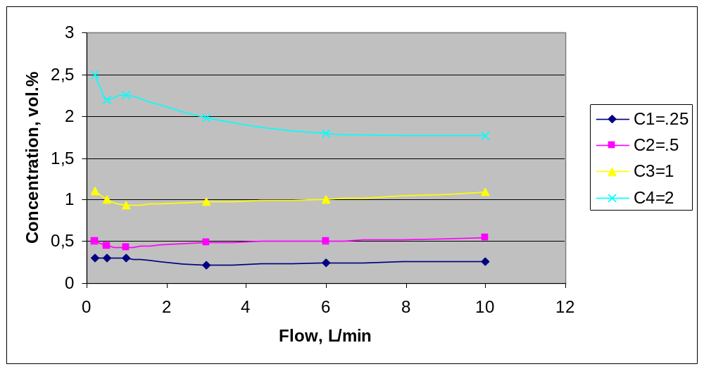

Fig. 6. Delivered concentration of the “MP-20” vaporizer at continuous flow range

To decrease delay in changing the anesthetic inspired concentration during low- or mini-flow anesthesia, install MV-20 IN the breathing circle (Fig. 8).
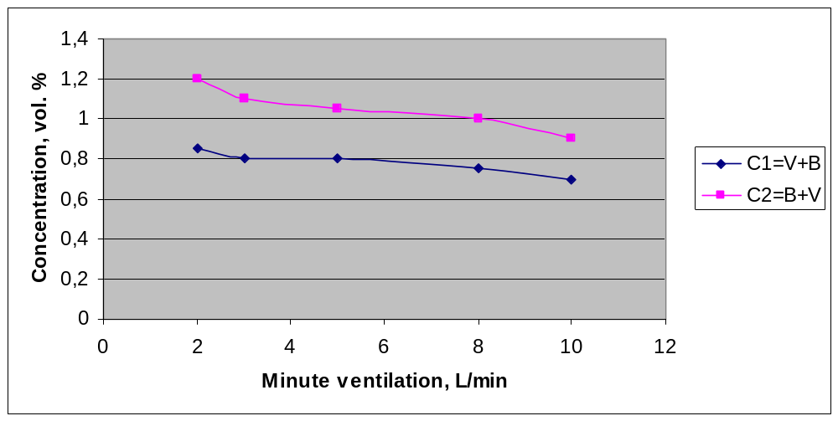

Fig. 7. Inspired sevoflurane concentration of MV-20/S vaporizer in the open circuit:
vaporizer inlet is open, the outlet is connected with a self-inflating bag (C1 = V + B); vaporizer inlet is connected with a self-inflating bag, the outlet is connected directly to a non-rebreathing valve (C2 = B + V)

There is instant change of inspired concentration C_{I} that will be much higher than the scale one C_{S} at high ratio of minute ventilation MV to fresh gas flow F_{G}:

C_{I} = C_{S} (1-C_{S})⁻¹ . MV . F_{G}⁻¹ (2)
Account concentration is reduced when high concentrations are set at the same time as a high gas flow, write down

C_{I} ≤ C_{S} . MV . F_{G}⁻¹ (3)

The last anesthesia method repeats popular (up 60-th year’s) draw-over anesthesia one but uses a more advanced vaporizer MV-20; just as an anesthetist can set approximately inspired concentration at any minute ventilation and fresh gas flow.
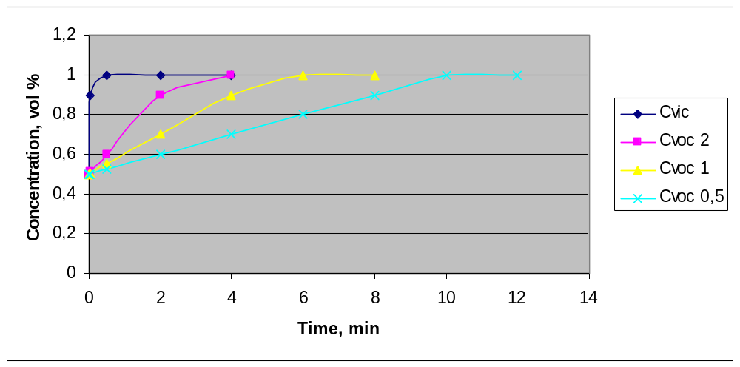
Fig. 8. Time of inspire anesthetic concentration change (delay) from 0,5 to 1 vol % in semi-closed circles after alteration of the vaporizer setting (“patient” – bag or bellow)
C_{VIC} – inspired concentration with VIC (MINIVAP-20, MV = 5 L/min, V_{T} = 0.4 L);
C_{VOC 2}, C_{VOC 1}, C_{VOC 0,5} - inspired concentrations with VOC (V_{C} = 5 L, F_{G} = 2; 1 and 0,5 L/min accordingly).

However there is VOC more safe and convenient during long anesthesia maintenance.
Sometimes may be used complex anesthesia method. When anesthesia induction or rapid anesthesia deepening, MV-20 is installed IN a circle (VIC enriches all inspired gas by anesthetic vapors during 2-5 min) by means of special valve (see Fig. 3); when maintenance – OUT of the one (VOC enriches only fresh gas).

Influence of fluctuations in pressure

The concentration delivered by MINIVAP vaporizer is virtually independent (±0,3 vol.% or ±20 % of the set value) of pressure fluctuation (back pressure) up to 500 mm H₂O at ventilation frequency 15 min⁻¹.

Influence of running time
Evaporation of anesthetic during operation cools the vaporizer. The temperature and saturation concentration decreases more rapidly the higher the concentration set and the higher the flow selected. The temperature compensation counters this and limits deviation delivered. The diagrams Fig. 9 show typical concentration curves, taken at 20 ºC and 3 L/min air.

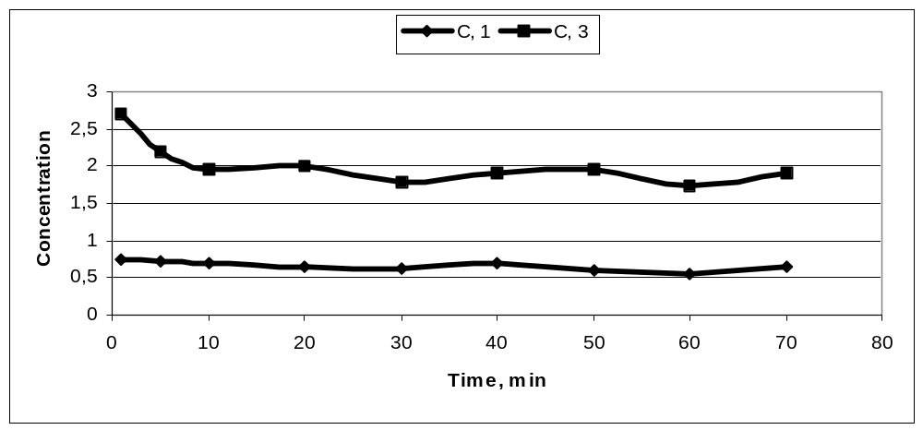
Fig. 9. Delivered concentration of the “MP-20” vaporizer in time

Behavior when tilted
Liquid anesthetic cannot to get to the bypass or to the outlet opening even if the vaporizer will be in the overturned position (filled up to 20 ml). But at a tilt position a part of porous metal wicks may be above the liquid anesthetic level so the saturation and the outlet concentration decreases at the high concentration set and the high flow selected. At the same time at the vertical and overturned positions the outlet concentrations are identical.

References
1. Sidorov V.A., Tcipin L.E., Grebennicov V.A. Pediatric Inhalation Anesthesia. MIA. M., 2010 – 184 p.p.
2. Pediatric Surgery (Moscow). 2008; No 4: 51-56.
3. Clinical Anesthesiology (Moscow). 2007, 4, No 5, 66-71; 2006, 3, No 5: 46-49.
4. Ru Patents No 2329069, 2372947 and Patent Applications No 2008100074, 2010123403.
5. www.rusanesth.com; www.medcom.ru; www.feldsher.ru; www.mitk-m.ru
“MINIVAP” Vaporizers and Anesthesia Machines (AM) were developed (3 patents and application for the invention) and are manufactured RU companies Scientific & Manufacture Venture Firm “MINIVAP” Ltd., “MITC-M” and AMNTC “UNION”

Head-Office Russia: 127273, Otradnaya Str. 1/76 Moscow :
berlin.minivap@googlemail.com

Office Germany: Huelser Str. 773, 47803 Krefeld

Office Israel: 44855, Kley Shir Str. 5/8 Karney Shomron

